Khai Phan Thanh

100901164

Law, Ethics and Social Responsibility (BTE620 - SBB)

Professor Xavier Scott

**IT and Me**

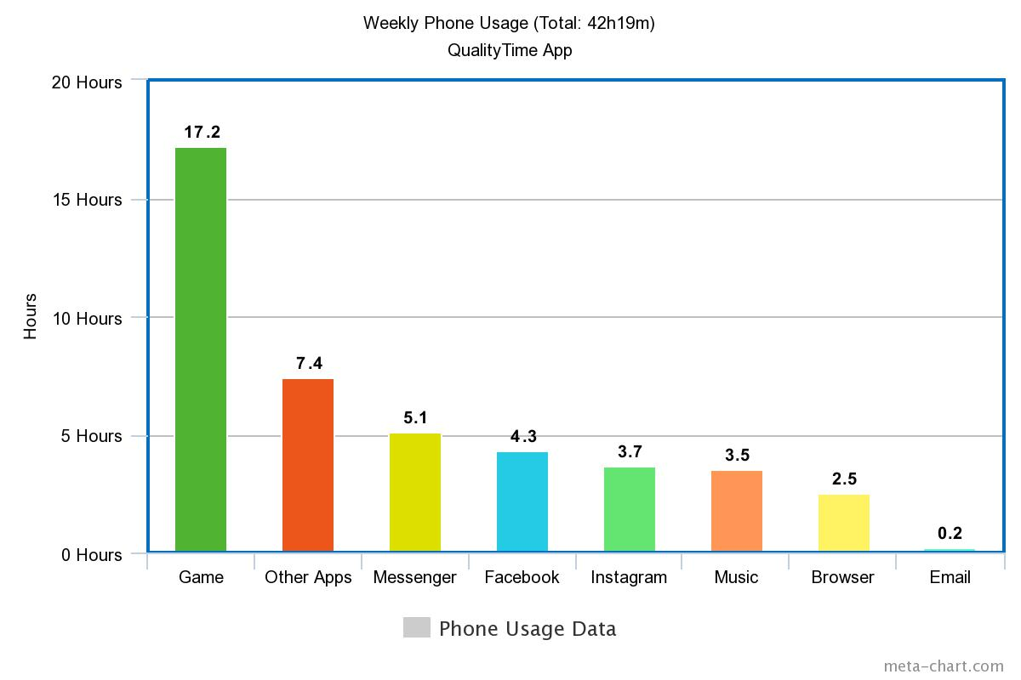

**Word Count: 916**

In recent decades, technology has been developed tremendously. With the creativity of human being, new technology ideas get invented every day, including smartphones and especially smartphone features. Smartphones are becoming the number one technology that every person must have on top of every other technology. It gives the user the power and support on their daily work or needs by continuously enhancing the features to meet their demands. Smartphones nowadays are getting so powerful, but it’s easy to get people addicted and distracted from their life and society.

There is an evolution of smartphones these years and it will still be growing rapidly on at least a few next decades. Each year, hundreds of new smartphones are released and each has its own strength and features to compete with other phone’s brand. According to *Statista*, there are currently about 4.6 billions of phone user worldwide, 50% of them are smartphone users, and not to include some person who owns more than 1 devices. Smartphone helps people to solve many different kinds of problems. Each year, customers are demanding extra features to meet their usage that forced phone’s company to develop their product continuously. Modern smartphones now can even perform like a laptop, it does have most of the laptop’s function, store as much as 1TB of data, can calculate super complex mathematics with its octa-core chip and have as much as 8GB of ram to handle everything. I personally prefer to use a smartphone over a laptop because it is portable convenient and it has most of the things I would need. My phone actually helps me a lot during my work or study if I need to do a quick information check or to access any resources. It is such a convenient device that meet the needs of all of my needs and I actually start getting addicted to the convenient and wonderful features it has.

Addicted to a smartphone has never been easier than ever. According to *Psychguides*, 90% of Americans own a smartphone and 56% of them has “Symptoms” of phone addiction such as checking their phone for every receiving notification or unable to have their phone taken away from them. As mentioned above, smartphones nowadays are affordable, handy, powerful. This allows more smartphone user than laptop user. According to my record, my daily average usage is at least 6 hours per day, and that is considered phone addicted. It also is shown that in the past week I have physically turned the screen on for at least 300 times. While on the smartphone, I can enjoy and entertain as long as I can and on my own. From talking with a friend through a camera, listen to your favourite music to watch and stream your favourite videos has never been that easy, and all in just one small handy pocket-sized device. Smartphones allow us to “customize” our favourites hobbies, therefore it makes us spend most of the time on it too. 40% of my time is for gaming and another 40% is using for social media and music which are all in my interest. Spending at least 6 hours a day on gaming and social media seems to isolate me from my study life and society where I should go meet them and talking face-to-face. Phones are attracting people from its benefits and start to make people from their society and life.

It is so easy nowadays to walk into a coffee shop and see 2 people sitting face-to-face, and each using their smartphone. That situation also happens with a group as well, where there could be only 2 or 3 people talking and the rest are using their phone. That is the downside of technology brought to us. Since we can “socialize” our life through a phone, more people start to talk less and read more. I am usually on the phone when I meet with my friend when we running out of idea and sometimes completely forgot the opposite person. Instead of using the phone I could have used that time to discover and understand more about my friend so we can have something to talk about. It also creates so much distraction in my study and as well as my work. Many times during my home study I was distracted just by a notification from a friend. With an average of 6 hours using the phone, I could have spent less time on the phone and focus on something that would actually help me. Sometimes I felt I am isolated to myself when I just keep playing those games, go on to social media while seating in a group despite how interesting the topic is. Overtaking the benefits of smartphones could lead to consequences that many users don’t realize.

Smartphones seem like a powerful tool that help people on their daily activity, however, its side effects are greater than it benefits. From enjoying the benefits, to get addicted and separate yourself with the phone, that happens really quick and once you get into it, it’s just like using drugs, hard to get out. In the future, I need to use some apps that help me to stay away from my phone so I can focus on my study as well as my work because I realized those time I spent on the phone will not help to improve my future.